DevOps Task – Day 1
GIT (Global Information Tracker) – Introduction and Installation
Field | Details
Name | Chandru
Date | 07-10-2026
Batch | 14
Topic | GIT – Introduction ,Installation , github repository creation

1. What is Git?
Git is used for source code management. It is a free and open-source version control system used to handle small to very large projects efficiently.
- Tracks changes in the source code
- Keeps a history of the code
- Tracks who made the changes
Git is a Distributed Version Control System (DVCS).

2. Source Code Management (SCM)
Source Code Management, also known as Version Control, is a system that helps developers track and manage changes to their software code.
It allows multiple developers to collaborate on a project by keeping a history of code changes, enabling easy rollback to previous versions, and facilitating teamwork without conflicts.

3. Version Control System (VCS)
Version control systems are tools that help developers manage changes to their code over time. They allow developers to collaborate on projects, track changes to code, and revert to earlier versions of code if needed.
Examples: Git, SVN, ClearCase, Mercurial, TFS

4. Types of Version Control Systems

Distributed Version Control System (DVCS)
A Distributed Version Control System is a type of VCS where every contributor has a complete copy of the project's entire history and can work independently. Git is a popular DVCS that enables decentralized collaboration and offline development.
Examples: Git, Bitbucket, CloudBees, AWS, Azure

Centralized Version Control System (CVCS)
A Centralized Version Control System is a type of VCS where there is a single central repository that stores the project's history. Developers must connect to this central server to access and update the code. Older systems like Subversion (SVN) are examples of CVCS.
Examples: ClearCase, SVN

5. GitHub
GitHub is a popular web-based platform for hosting and managing source code using Git, a distributed version control system (DVCS).
It provides tools for collaboration, such as issue tracking, pull requests and code reviews, making it widely used by developers and teams for open-source and private projects.

6. Features of Git
- Tracks history
- Free and open source
- Supports non-linear development
- Creates backups
- Scalable
- Supports collaboration
- Branching is easier
- Distributed development

7. Benefits of Using Git
Benefit | Description
Distributed Version Control | Every developer has a local copy of the codebase. This allows developers to work offline and makes it easier to collaborate with others.
Branching and Merging | Git makes it easy to create branches of code, so developers can work on features or fixes without affecting the main codebase, and then merge changes from one branch to another.
History and Tracking | Git tracks every change made to the codebase, including who made the change and when. This makes it easy to see the history of the codebase and to track down bugs or issues.
Collaboration | Multiple developers can work on different branches of the codebase and then merge their changes together.

8. What is a Git Repository?
A Git repository is the place where all the Git files are stored. These files can be stored in a local repository or in a remote repository.

Local Repository
A local repository is a copy of a Git repository stored on your local machine. It contains all the files and the complete version history of the project.
You typically create a local repository when you start a new project or when you clone an existing remote repository to your local machine.

Remote Repository
A remote repository is a Git repository hosted on a remote server, which could be on the web or a network location.
Examples: GitHub, GitLab and Bitbucket host remote repositories.

9. Git Installation on Different Platforms
The installation process for Git varies depending on the operating system you are using.

Linux (Ubuntu)
Use your distribution's package manager. On Ubuntu, run:
sudo apt-get install git

Check the installed version
git --version
Displays the version of Git installed on your machine.

Windows
Download the installer from the official Git website, run it and follow the on-screen instructions.
https://git-scm.com/download/win

Mac
Git comes pre-installed on most Macs. You can also download the installer from the official Git website, run it and follow the on-screen instructions.
https://git-scm.com/download/mac

10. Creating a GitHub Account and Repository

Step 1 – Create a GitHub account
- Go to https://github.com/
- Sign up with your email address.
- Verify your email address. Once verified, the account is created.

Step 2 – Open your repositories
- Click the three lines (menu) at the top left.
- Click All repositories.
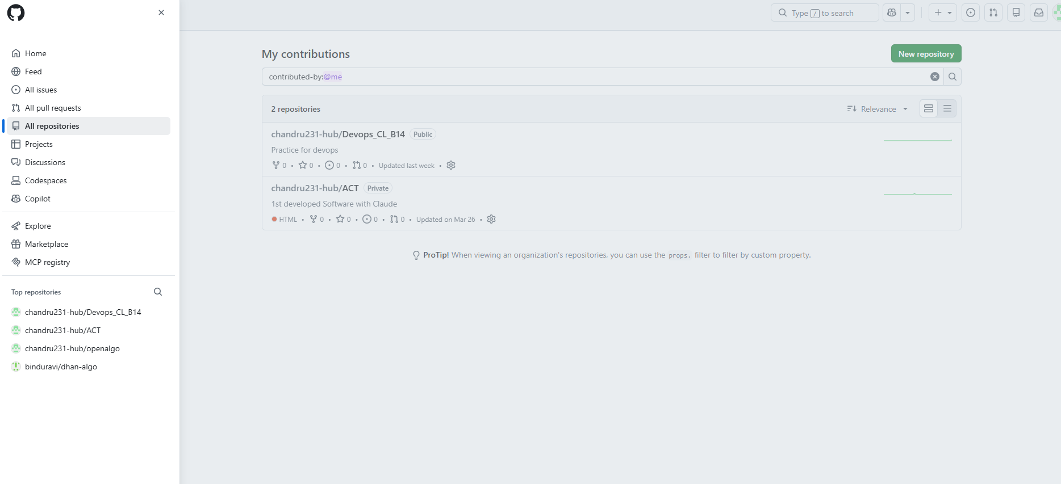
Menu (three lines) → All repositories

Step 3 – Create a new repository
- At the top right, click New repository.
- Repository name: chandru
- Description (optional): Batch 14
- Tick Add README.
- Click Create repository at the bottom right.
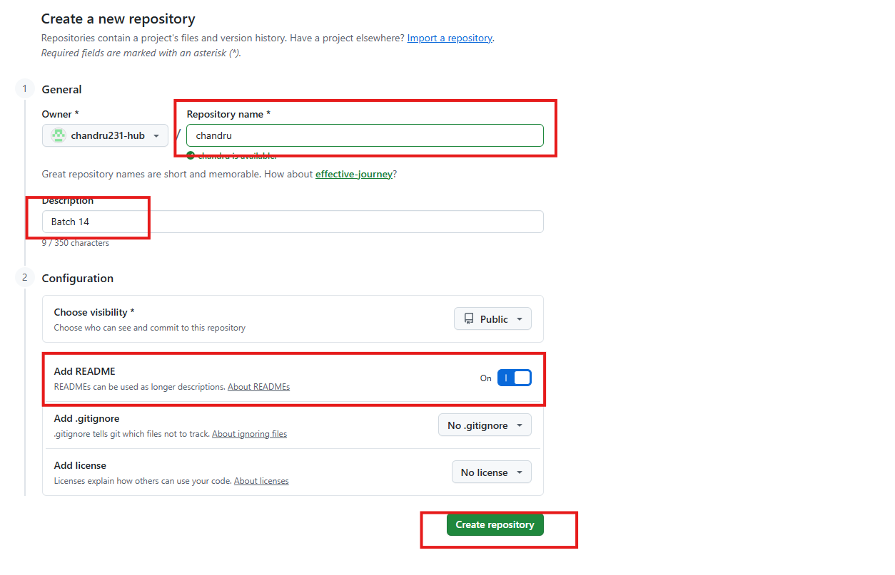
New repository form – name, description and Add README

Step 4 – Repository created
The repository chandru is now created on GitHub with a README.md file and its first commit ("Initial commit") on the main branch.
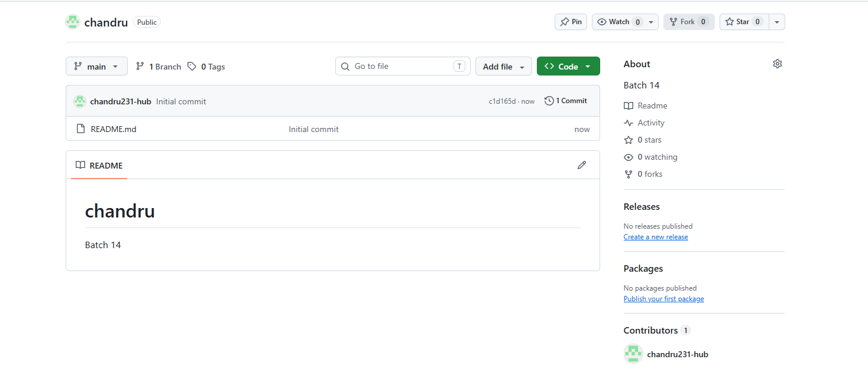
Repository created – README.md, main branch, 1 commit

